- What is a factory function?
- A function that takes an objects as an argument and then modifies it.
- A function that returns an array of objects.
- A function that returns an object.
- What is a method?
- A method is a function that takes an object as its parameter.
- A method is a property with a function as its value.
- A method is general term used to describe how to create objects.
- What’s wrong with setter method in the example below?
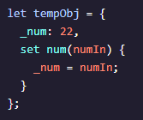
- The setter should contain this._num in place of _num.
- The setter input argument should be called num.
- The _num key should not have an underscore (_) in it.
- There is nothing wrong with the methods.
- What are the keys in this objects?
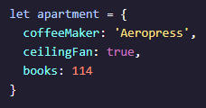
- 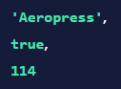
- 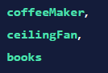
- 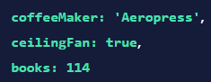

- Which is the correct syntax for creating an object literal?
- 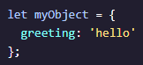
- 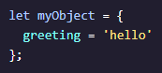
- 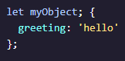
- 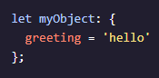
- Given the following code, which expression will evaluate to apples?
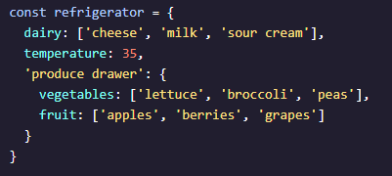
- refrigerator.temperature
- refrigerator[‘produce drawer’]
- refrigerator[‘produce drawer’].fruit[0]
- refrigerator.‘produce drawer’.fruit[0]
- What will the following code output?
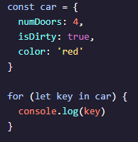
- 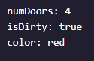
- 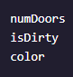
- 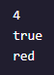
- Which variables possess block scope?
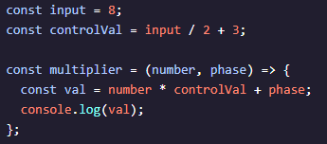
- number, phase, val
- input, controlVal
- val, number, controlVal, phase
- input, controlVal, multiplier
- What will be the output of this code?
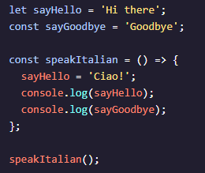
- 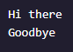
- 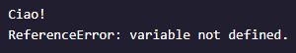
- 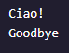

- How many global variables are there in the following block of code?
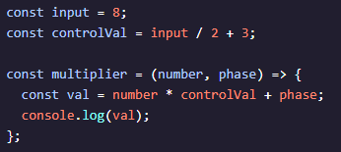
- There are four: input, controlVal, val and multiplier.
- There are three: input, controlVal, and val.
- There are three: input, controlVal, and multiplier.
- There are two: input and controlVal
- What will be the output of this code?

 